**Project Development Phase**

**Sprint – 2 Report**

|  |  |
| --- | --- |
| Date | 6 November 2022 |
| Team ID | PNT2022TMID37692 |
| Project Name | **Personal Expense Tracker Application** |

**1. Flask – done**

**installation and Started working**

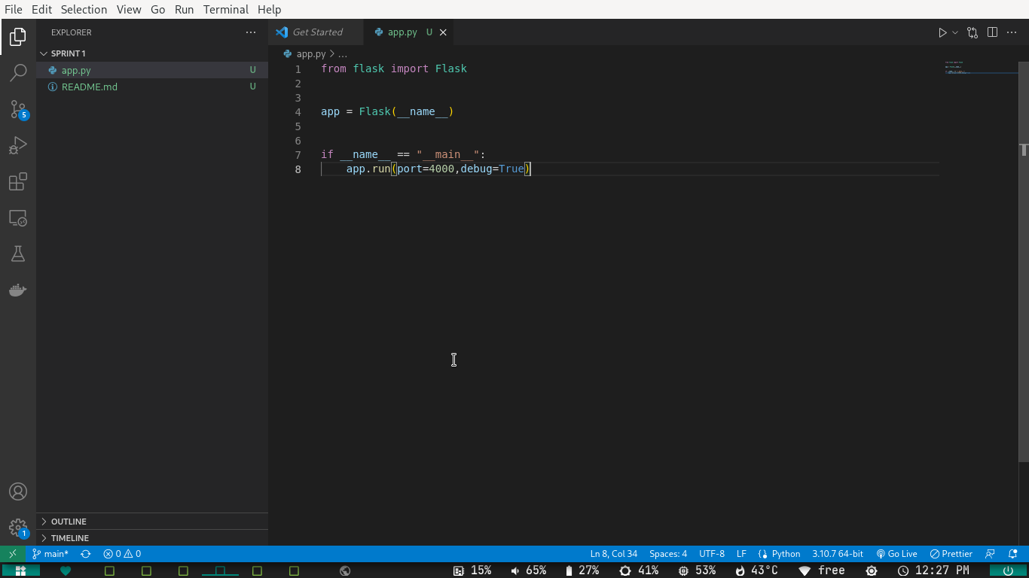**IBMcloud – done**

**Account created**

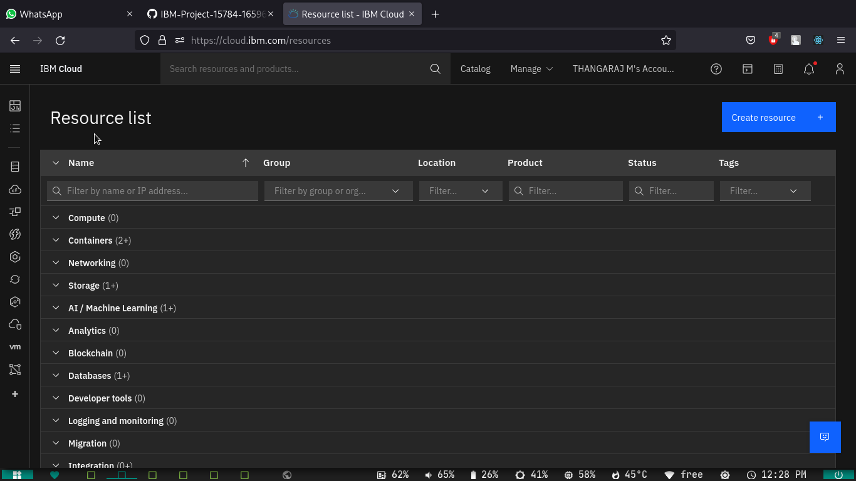

**Cli installed**

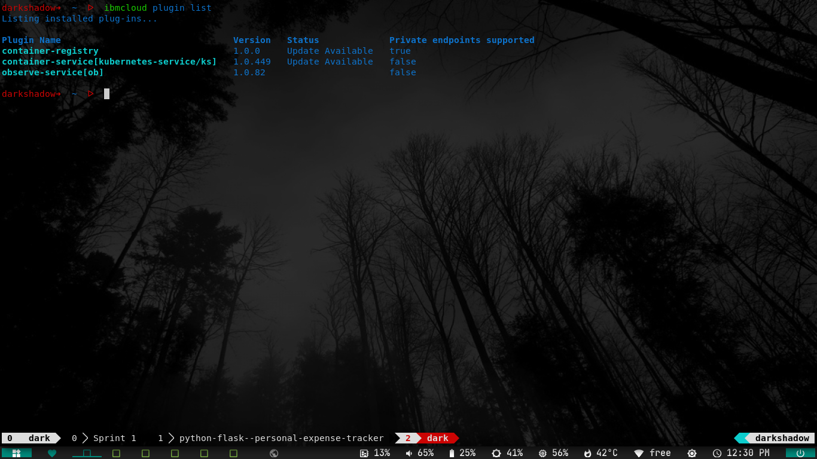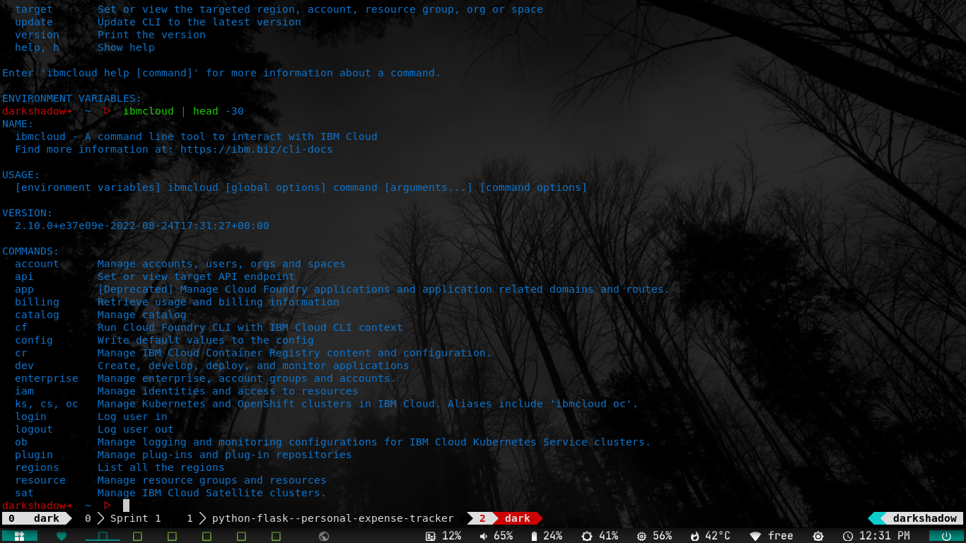

**Docker Installed**

